Dallas Christian Academy
4025 N. Central Expressway
Dallas, TX 75204
214 528-6327
info@dallaschristianacademy.org

Uniform Information
2018-2019
The following information provides details on uniforms for daily wear, chapel wear,
physical education, and any athletic/sports practices. (PE classes include all classes
that change their clothes like 5th through 12th grade.)

Lower School Daily Wear (PreK-1st)
- Baby blue polo (long or short sleeve, with school logo)
- Navy blue jumper (Girls)
- Navy blue docker style pants (Boys)
- Solid black or brown belt (to use for pants or shorts)
- Solid white, black, or brown shoes (No other color on shoe, must be solid)
- Navy color sweater no hoodies (optional, logo is not required)
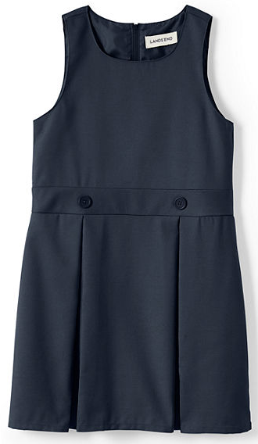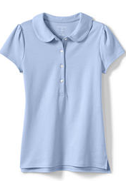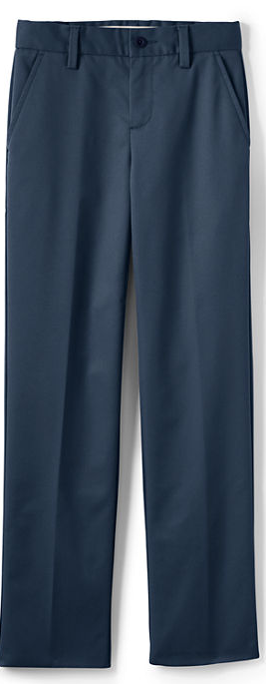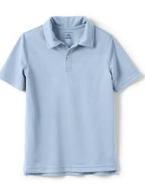

Lower School Daily Wear (2nd -8th grade)
- Baby blue button down oxford (long or short sleeve, with school logo)
- Navy blue pleated skirts below the knee (Girls)
- Navy blue docker style pants (Boys)
- Solid black or brown belt (to use for pants or shorts)
- Solid white, black, or brown shoes (No other color on shoe, must be solid)
- Navy color sweater, no hoodies (optional, logo is not required)
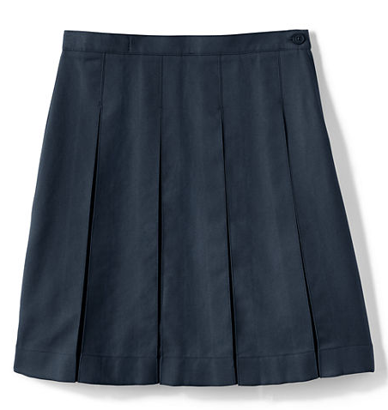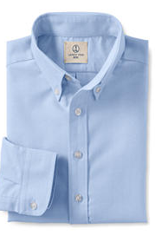

Upper School Daily Wear (9th-12th grade)
- Baby blue button down oxford (long or short sleeve, with school logo)
- Navy blue pleated skirts below the knee (Girls)
- Solid Khaki docker style pants (Boys)
- Solid black or brown belt (to use for pants or shorts)
- Solid white, black, or brown shoes (No other color on shoe, must be solid)
- Navy color sweater, no hoodies (optional, logo is not required)
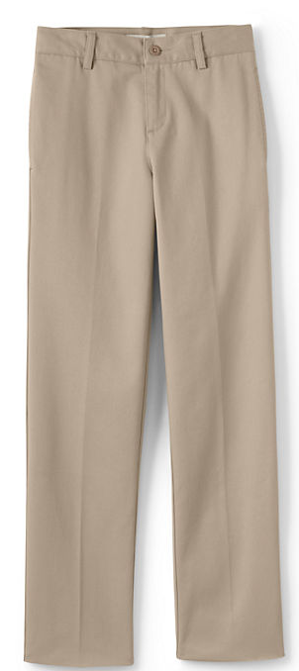

Chapel Uniform will be same as Daily Uniform with the following exceptions:
Lower School (Prek-1st) Red tie and white polo (school logo optional)
Girls 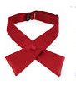 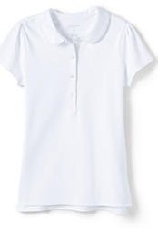 Boys 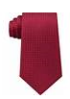 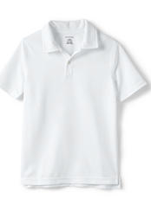
Lower School (2nd-8th) Red tie and white button down oxford (long or short sleeve, logo optional)
Girls 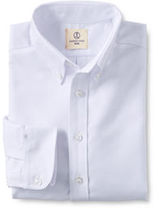 Boys

Upper School (9th-12th) Navy blue tie, navy jacket, and white button down oxford (long or short sleeve, logo optional)
Girls & Boys tie, white oxford, & jacket 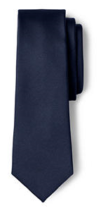 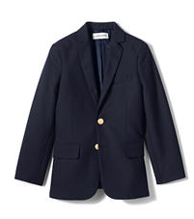

Website for girl jumper/skirts, jackets, and more: LandsEnd.com
Lands.End.com has an option for below the knee. Collin Creek Mall (in the Sears store on the first floor) has samples that children may try on for sizing.
Skirt length below the knee is acceptable – in compliance
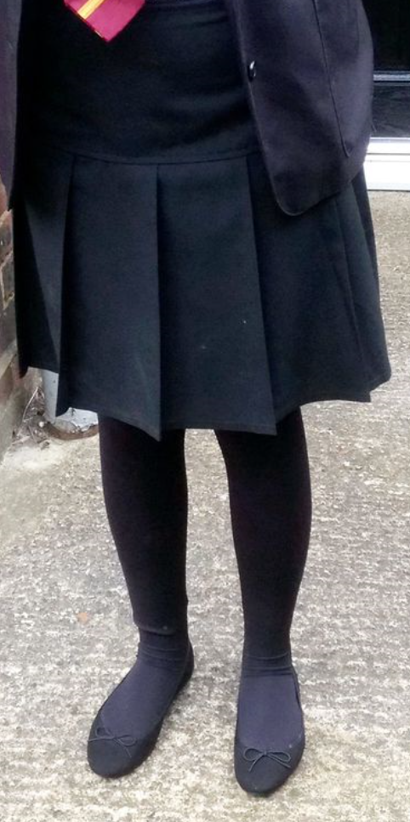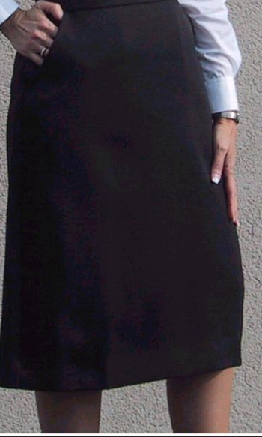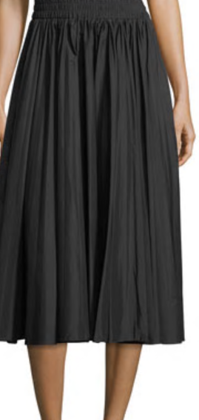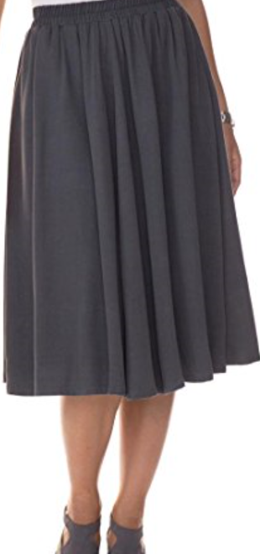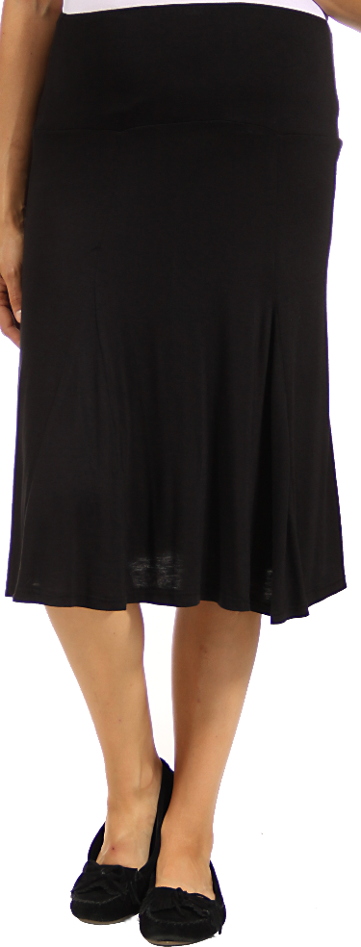

Skirt length that is above the knee not acceptable – above the knee is not in compliance
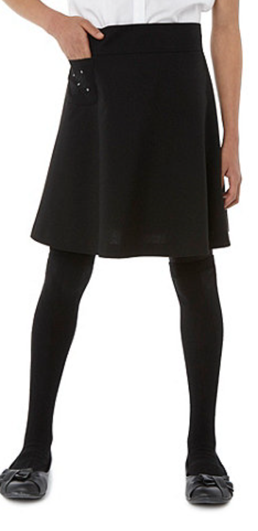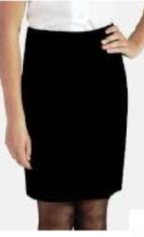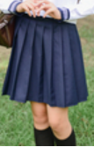
Dallas Christian Academy Logo
The school logo is required for all daily wear shirts
(all other wear is optional for the logo).

Two ways to purchase clothing with the school logo
- LandsEnd.com is an online vendor with the school logo.
Shirts, sweaters, jackets, may be purchased with the school logo.
www.LandsEnd.com

- Affordable Uniforms is a local store that will have the logo embroidered on the shirt. You must take the clothing items to theirs shop for embroidery.
The charge is $6.00.
The Address: Affordable Uniforms Affordable Uniforms Number
7014 Bruton Rd (214) 206-1977
Dallas, TX 75217

Accessories may be purchased where available in stores or online.

Red Ties Navy Blue Ties for upper school
Solidcolornecties.com solidcolornecties.com
About $6.00 About $6.00

Beltoutlett.com
Kids 1 inch adjustable belt magnetic (JK-319-BLK)
About $4.00
Magnetic belts are optional.
A magnetic belt is helpful when the younger students need to practice
their fine motor skills.

Socks/Shoes/Modesty Shorts
Navy blue, black socks, ankle or knee high
White socks ankle
To the knee or ankle
(White ankle socks may be worn with white shoes.)
Solid black, white shoes, or Tan only shoes.
Modesty shorts, black or navy blue
Shoes that are acceptable – in compliance 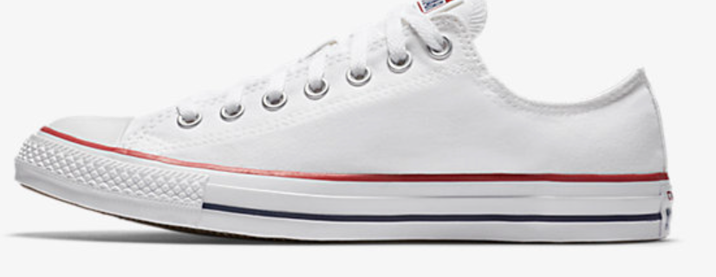
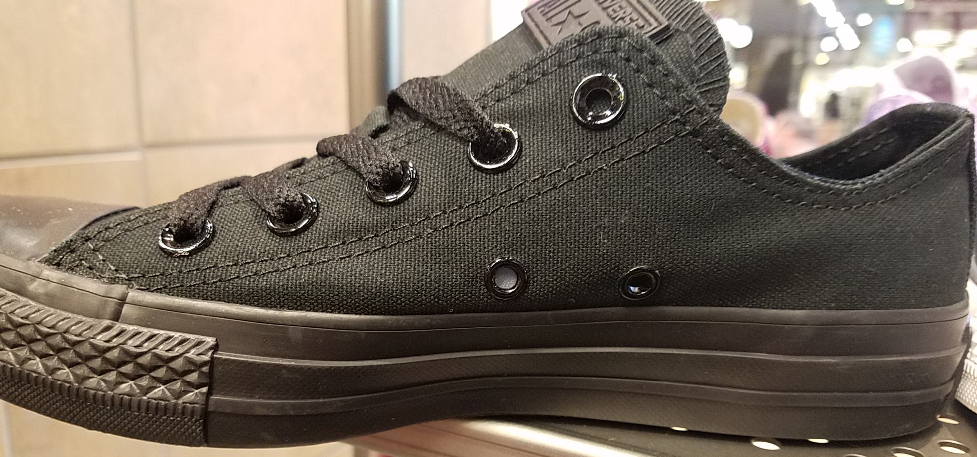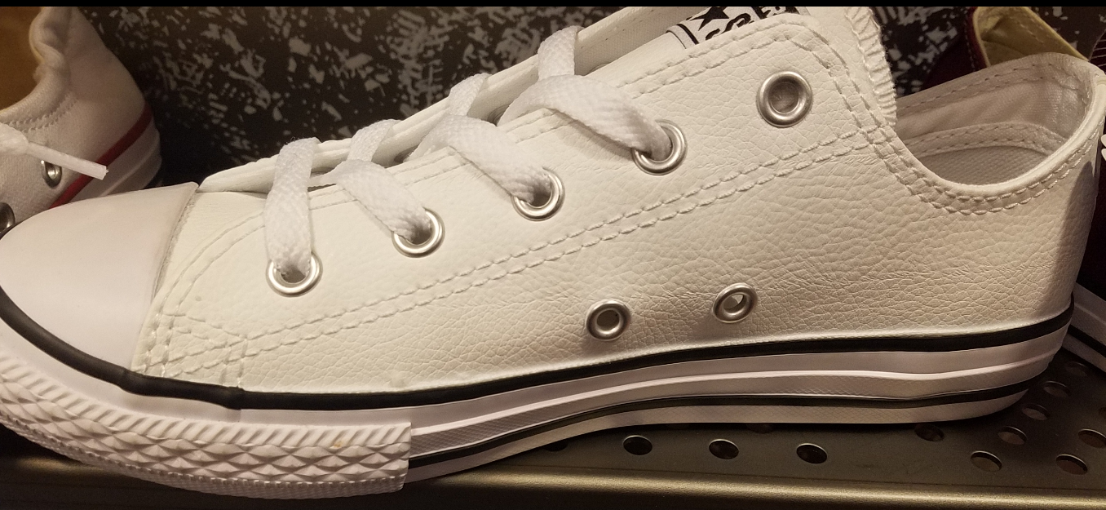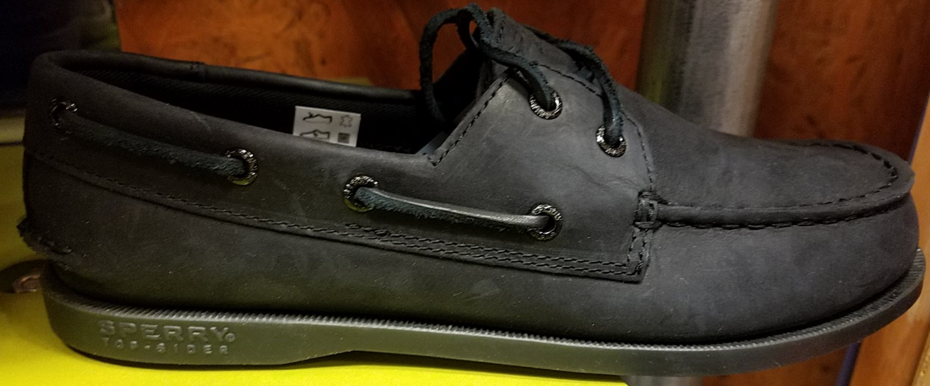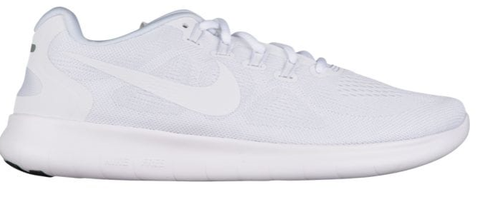
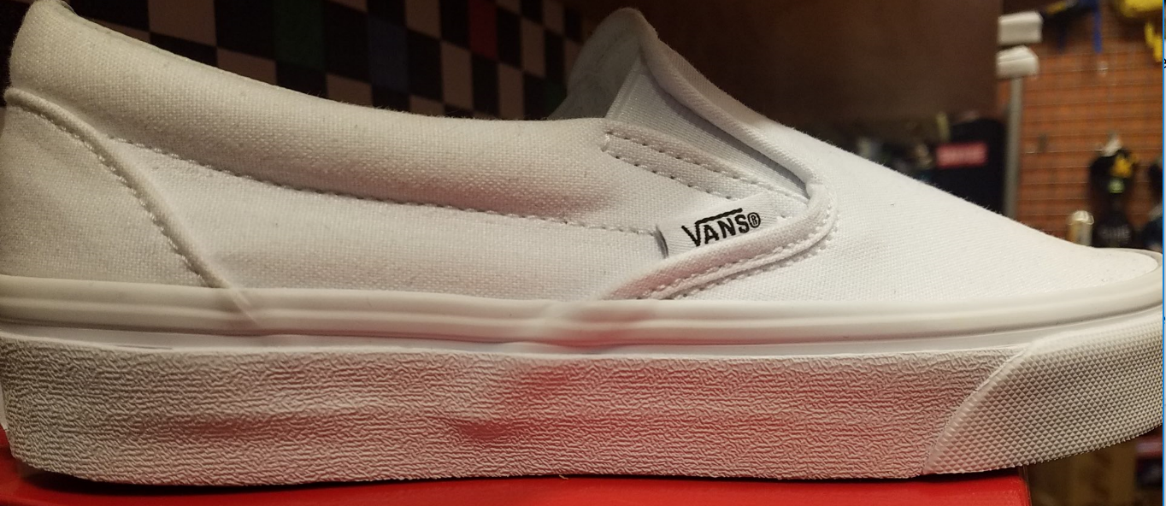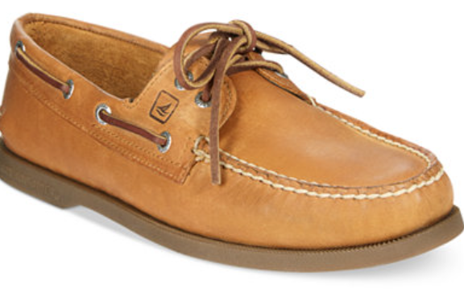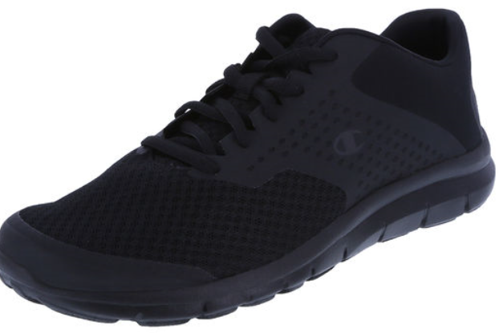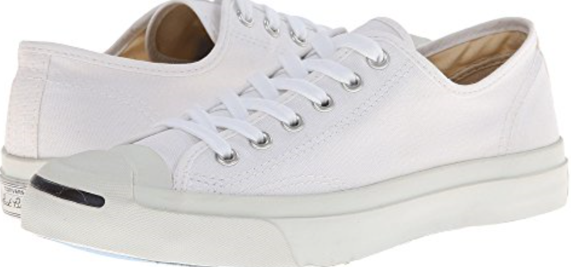
Shoes that are not acceptable – out of compliance
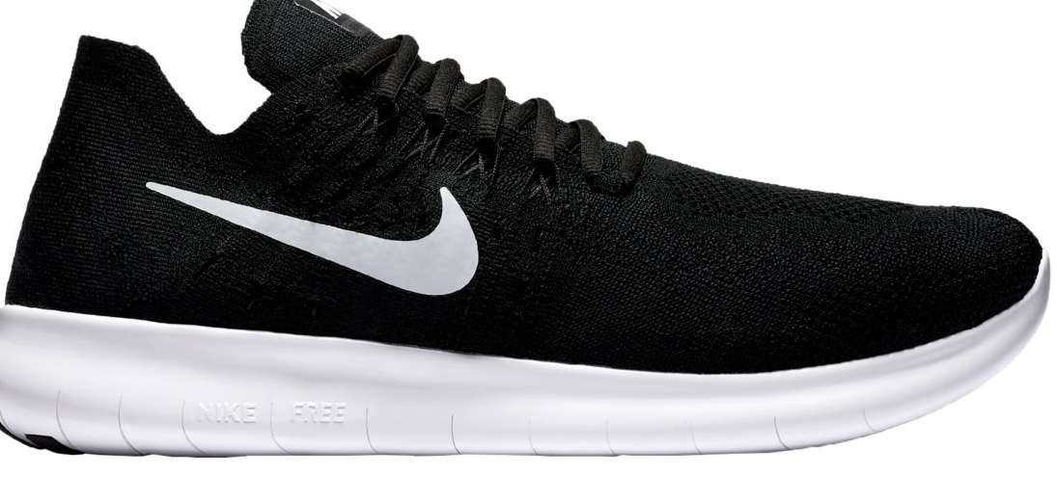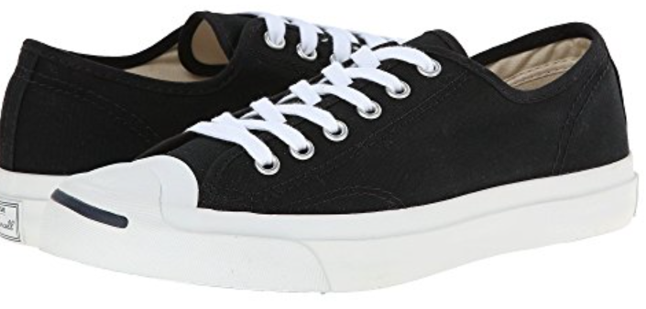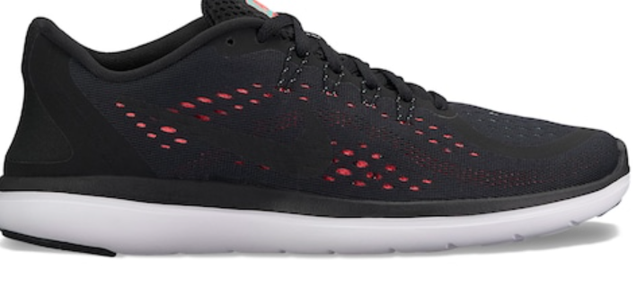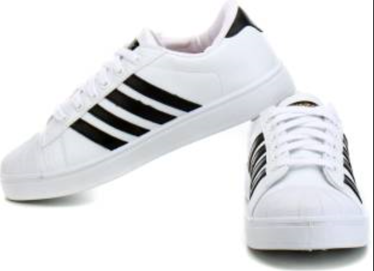
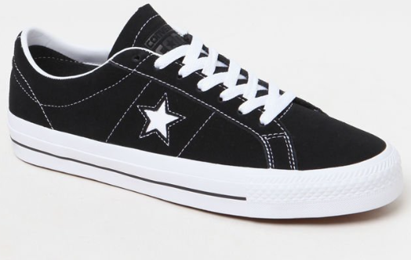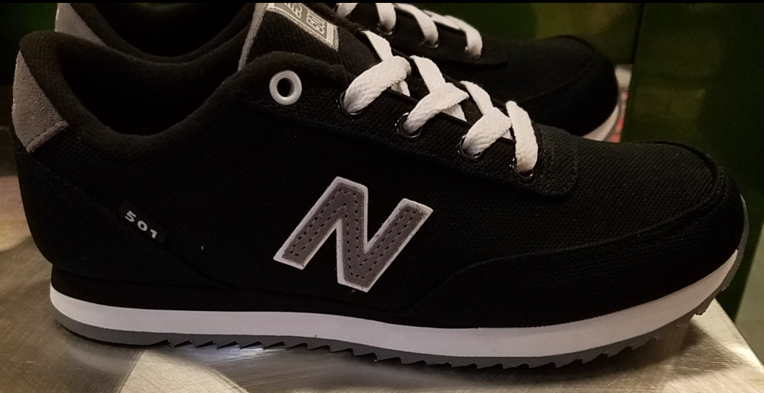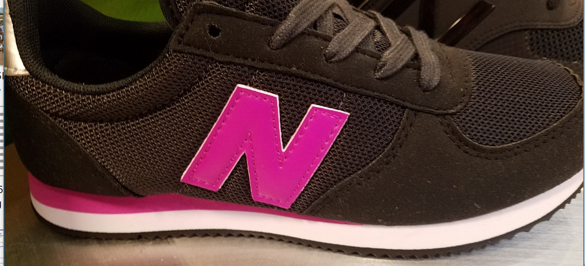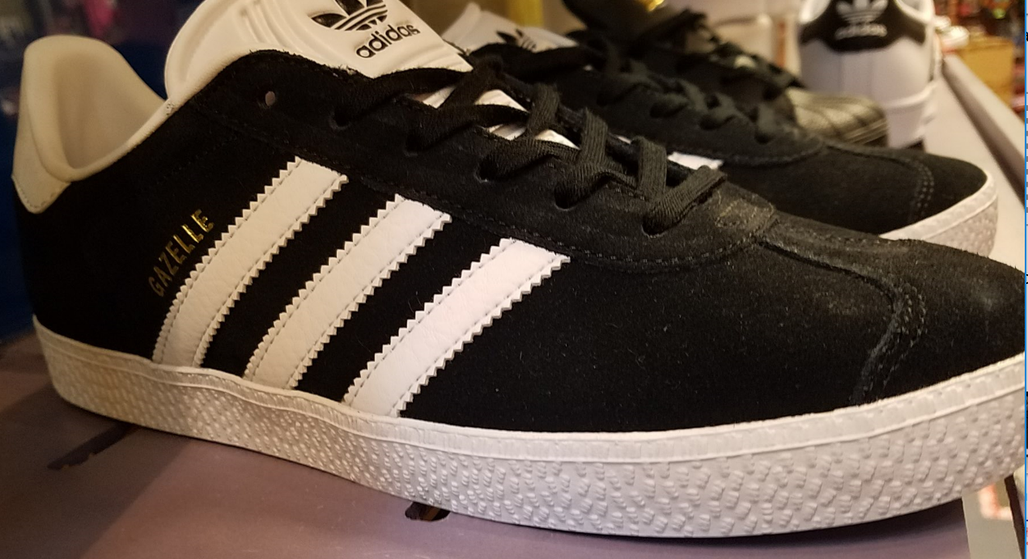
Please read the student handbook carefully regarding consequences for students who are out of compliance.
Accessories
Navy sweaters: zip front, vest, button down, cardigan with pockets, pull over v-neck or crew sweaters are acceptable for all girls and boys. School logo is optional. Hoodies are not allowed to be worn in class.
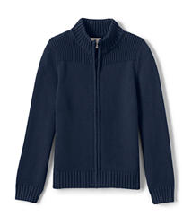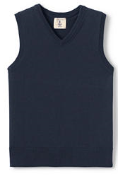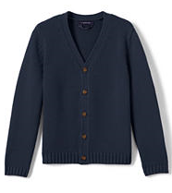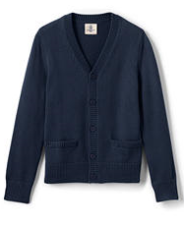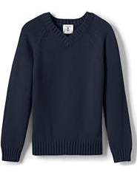
Male students are required to wear belt and socks daily. Female students required to wear knee socks, modesty shorts or leggings to the ankle daily.
Boys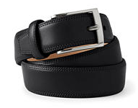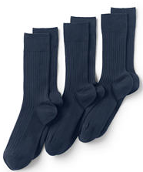 Girls 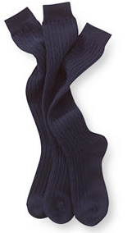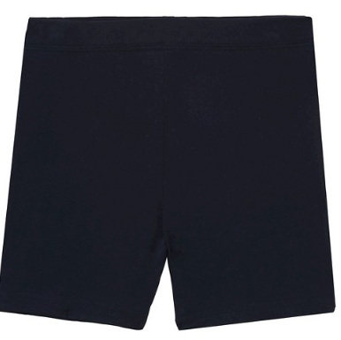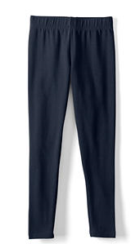

Physical Education and any Athletic or Sports Practice Uniforms

Athletic wear may be purchased at stores where available.
Black Shorts or loose fitting sweats Red T-shirts
Black Basketball shorts to the knee Red t-shirts to the hip for tucking in
Black modesty shorts under shorts Red t-shirt loose fit
Black, loose fit sweats – nothing body Red t-shirt school logo optional
Fitted or tight (no yoga pants) (No inappropriate wording or pictures)
Appropriate Wear – in compliance
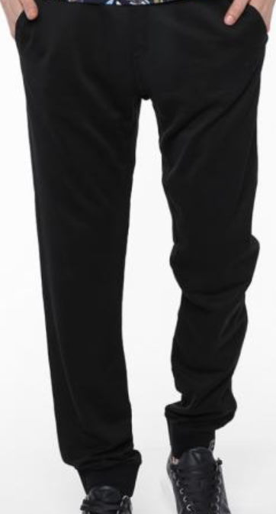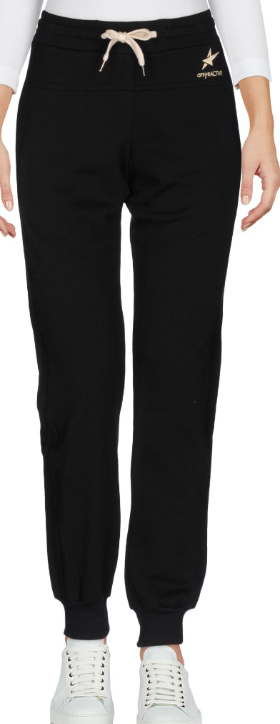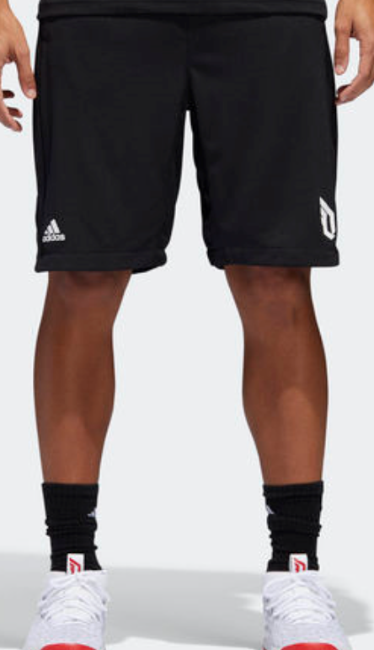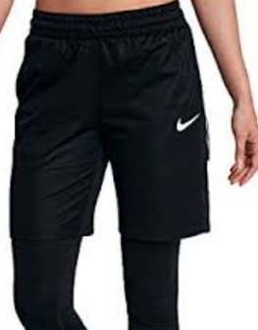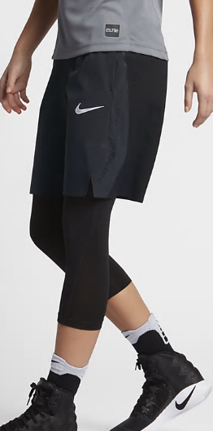

Inappropriate wear – out of compliance
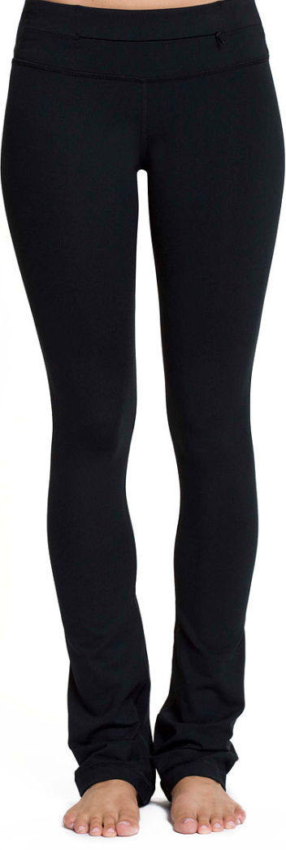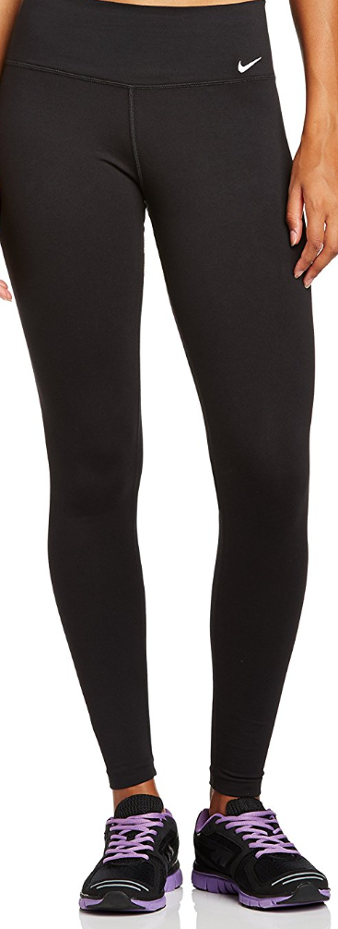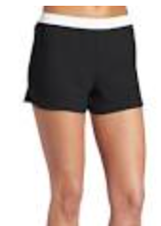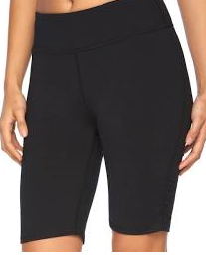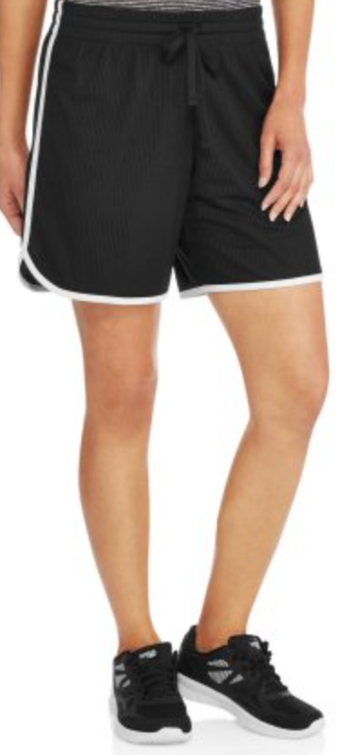

All clothing must be in compliance and representative of a respectful character towards the expectations set forth within the handbook and uniform information guide.

